Appendix 1 Area of Competence of the Convention on the Conservation and Management of Highly Migratory Fish Stocks in the Western and Central Pacific Ocean
WCPFC Convention Area
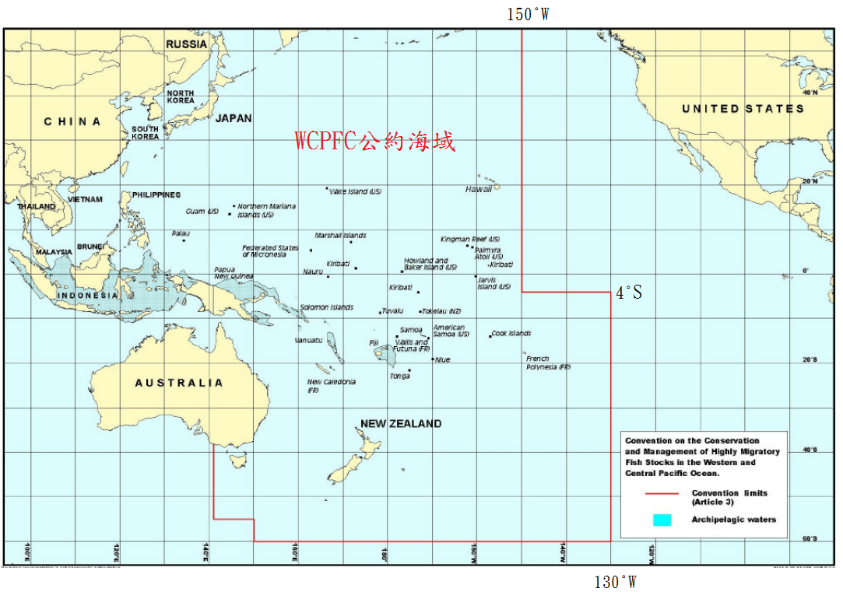
Appendix 2 Area of Competence of the Convention for the Establishment of an Inter-American Tropical Tuna Commission and the Convention for the Strengthening of the Inter-American Tropical Tuna Commission Established by the 1949 Convention between the United States of America and the Republic of Costa Rica

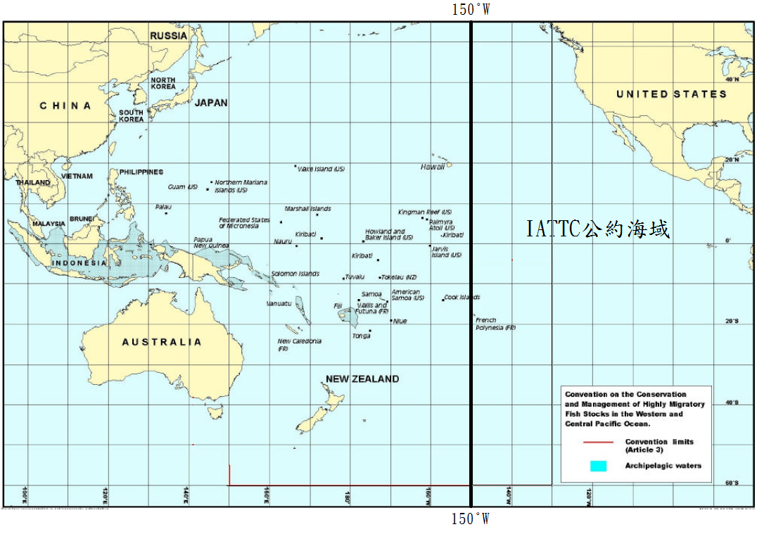
IATTC Convention Area

Appendix 3 Bigeye Tuna Fishing Area for Fishing Vessels of 100 GT and above in the Pacific Ocean
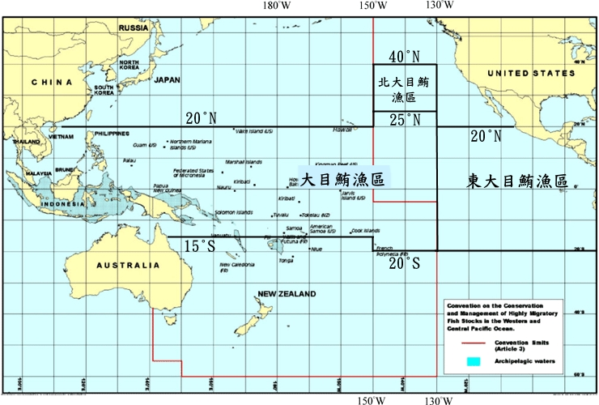

North Bigeye Tuna Fishing Area

East Bigeye Tuna Fishing Area
Bigeye Tuna Fishing Area

Appendix 4 Albacore Tuna Fishing Area for Fishing Vessels of 100 GT and above in the Pacific Ocean

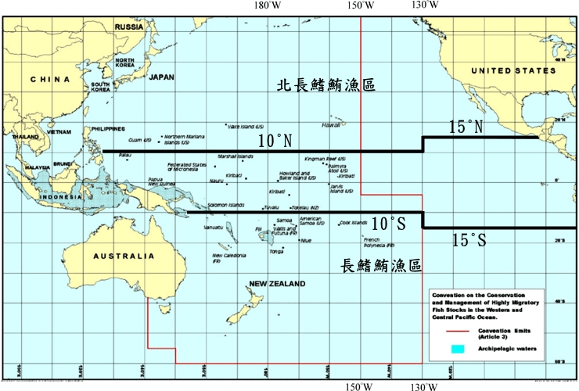

North Albacore Tuna Fishing Area

Albacore Tuna Fishing Area

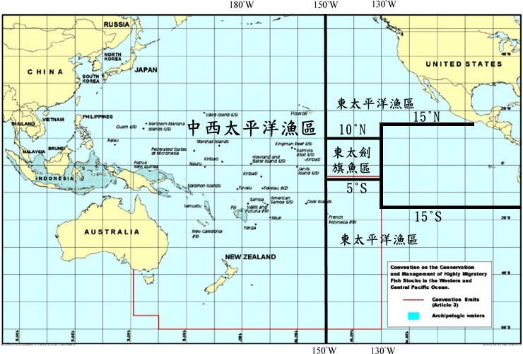
Appendix 5 Fishing Area for Tuna Longline Fishing Vessels of 20 GT and above and under 100 GT in the Pacific Ocean

Eastern Pacific Fishing Area

Western and central Pacific Fishing Area
Eastern Pacific Swordfish Fishing Area
Eastern Pacific Fishing Area
Appendix 6
Application Form for Large Scale Longliners Operating in the Pacific Ocean
Registration Number of Fishing Vessel | CT － |  | Vessel Name in Chinese
 |  |  | Vessel Name in English
Distant Water Fisheries Operator | Name of Individual
 | Name of Company
 | The Legal Representative
 | Contact Person
 | Contact Address
 | Contact Telephone No.
Group of Fishing Vessel | □ Bigeye Tuna Group  □Applying to Fish in the East Bigeye Tuna Fishing Area  □Albacore Tuna Group  □Applying to Fish in the North Albacore Tuna Fishing Area |  |  | Ultra-low temperature devices |  |  | □Yes  □No
Satellite Communication and VMS equipment | VMS Type | □ARGOS |  | Type
 |  | □INMARSAT
 |  | ALC number:
 | Satellite Telephone No. | (required)
□The receipt issued by OFDC to the distant water fisheries operator for the payment of annual VMS communication fee.

Name of Applicant: (Signature or Stamp)
To Council of Agriculture:
Date:

Appendix 7
Application Form for Small Scale Longliners Operating in the Pacific Ocean

Registration Number of Fishing Vessel | CT － |  | Vessel Name in Chinese
 |  |  | Vessel Name in English
Distant Water  Fisheries Operator | Name of Individual
 | Name of Company
 | The Legal Representative
 | Contact Person
 | Contact Address
 | Contact Telephone No.
Group of Fishing Vessel | □Frozen Yellowfin Tuna Group  □SeasonalSharks Group □General Group  □Apply for Fishing in the Eastern Pacific Fishing Area  □Apply for Fishing in the Eastern Pacific Swordfish Fishing Area |  |  |  | Type of Storage | □Chilled  □Frozen  □Ultra-low temperature（below -50℃）
Target Species | Yellowfin Tuna Albacore Tuna Sharks  Mahi Mahi Billfishes Others (Please specify species)
Satellite Communication and VMS equipment | VMS Type | □ARGOS |  |  | Type
 |  | □INMARSAT
 |  | ALC number：
 | Satellite Telephone No. | (required)
□The receipt issued by OFDC to the distant water fisheries operator for the payment of annual VMS communication fee.

Name of Applicant: (Signature or Stamp)
To Council of Agriculture:

Date:

Appendix 8
Application Form for Tuna Purse Seine Fishing Vessels Operating in the Pacific Ocean
Registration Number of Fishing Vessel | CT － |  | Vessel Name in Chinese
 |  |  | Vessel Name in English
Distant Water Fisheries Operator | Name of Company
 | Legal Representative
 | Contact Person
 | Contact Address
 | Contact Telephone No.
Satellite Communication and VMS equipment | VMS Type | □ARGOS |  | Type
 |  | □INMARSAT
 |  | ALC number:
 | Satellite Telephone No. | (required)
□The receipt issued by OFDC to the distant water fisheries operator for the payment of annual VMS communication fee.

Name of Applicant: (Signature or Stamp)
To Council of Agriculture:
Date:

Appendix 9
Application Form for Carrier Vessels of the Republic of China
Registration Number of Fishing Vessel | CT － |  | Vessel Name in Chinese
 |  |  | Vessel Name in English
Distant Water Fisheries Operator | Name of Company
 | Legal Representative
 | Contact Person
 | Contact Address
 | Contact Telephone No.
Satellite Communication and VMS equipment | VMS Type | □ARGOS |  | Type
 |  | □INMARSAT
 |  | ALC number:
 | Satellite Telephone No. | (required)
Fishing Area | □ Pacifc Ocean □ Indian Ocean □Atlantic Ocean
□The receipt issued by OFDC to the distant water fisheries operator for the payment of annual VMS communication fee.

Name of Applicant: (Signature or Stamp)
To Council of Agriculture:
Date:

Appendix 10
Specification of Width, Height and Color of Characters for
Vessel Markings
I. Chinese Vessel Name
1. Height Standard of Characters
GT of Vessel |  | Minimum Length
20 GT and above and less than 100 GT |  | 25 cm
100 GT and above and less than 1,000 GT |  | 30 cm
1,000 GT and above |  | 35 cm
2. Color of Characters
Ground Color of Fishing Vessel | Color of Characters
Dark Color | White
Bright Color | Black

II. English Vessel Name and CT Number
1. Height Standard of Characters
GT of Vessel |  | Minimum Length
20 GT and above and less than 100 GT |  | 15 cm
100 GT and above and less than 1,000 GT |  | 20 cm
1,000 GT and above |  | 25 cm
2. Color of Characters
Ground Color of Fishing Vessel | Color of Characters
Dark Color | White
Bright Color | Black

III. IRCS
- Height Standard of Characters
Position of Marking | Vessel Length Overall |  |  | Minimum Length
Both Sides of the Vessel | 25 meters and above |  |  | 1 meter
 | 20 meters and above and less than 25 meters |  |  | 80 cm
 | 15 meters and above and less than 20 meters |  |  | 60 cm
 | 12 meters and above and less than 15 meters |  |  | 40 cm
 | 5 meters and above and less than 12 meters |  |  | 30 cm
 | Less than 5 meters |  |  | 10 cm
Deck | 5 meters and above |  |  | 30 cm
- Width Standard
Marking Items |  |  | The Proportion of Marking Items to the Height
Width of Hyphen |  |  | Half
Stroke Width of Characters or Hyphen |  |  | One-sixth
Space between Characters |  |  | One-sixth and above and less than one-fouth
Adjacent Space of Characters with  Hypotenuse Form (such as Ａ,Ｖ） |  |  | One-tenth and above and less than one-eighth
- Color of Characters
Ground Color of Fishing Vessel |  | Color of Characters
Dark Color |  | White
Bright Color |  | Black

Appendix 11 Figure of Shark Line
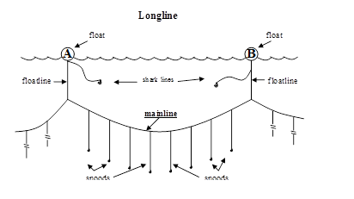

Appendix 12 De-hooker (left) and Scoop net (right)
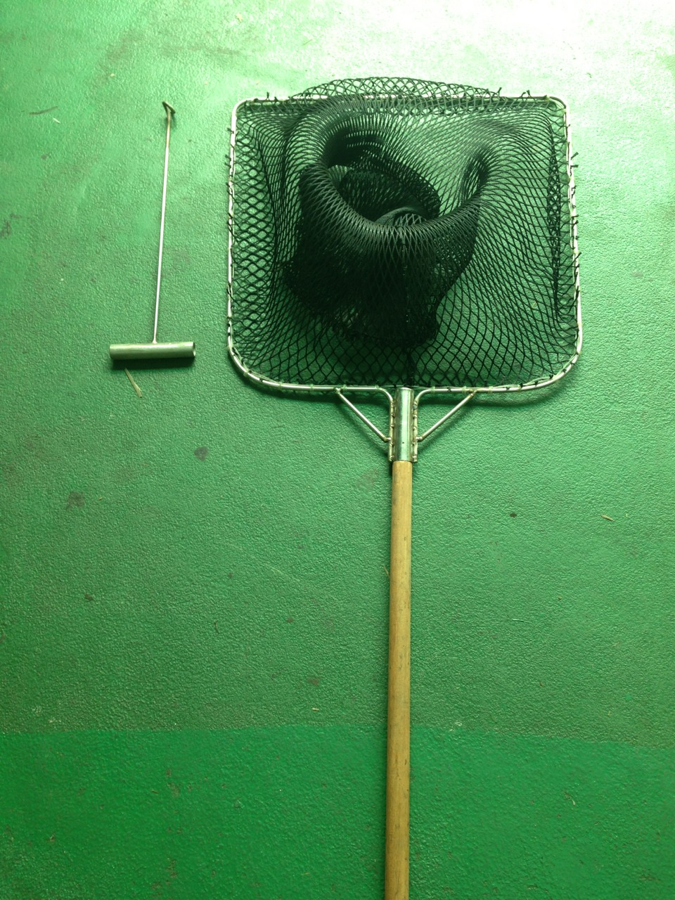

Appendix 13

Specification of Seabirds Mitigation Measures
in the WCPFC Convention Area
    - Tori lines (South of 30o South)
1a) For vessels >=35 m total length
      - Deploy at least 1 tori line. Where practical, vessels are encouraged to use a second tori line at times of high bird abundance or activity; both tori lines shall be deployed simultaneously, one on each side of the line being set. If two tori lines are used, baited hooks shall be deployed within the area bounded by the two tori lines.
      - A tori line using long and short streamers shall be used. Streamers shall be: brightly coloured, a mix of long and short streamers.
        - Long streamers shall be placed at intervals of no more than 5m, and long streamers must be attached to the line with swivels that prevent streamers from wrapping around the line. Long streamers of sufficient length to reach the sea surface in calm conditions must be used.
        - Short streamers (greater than 1m in length) shall be placed no more than 1m apart.
      - Vessels shall deploy the tori line to achieve a desired aerial extent greater than or equal to 100m. To achieve this aerial extent the tori line shall have a minimum length of 200m, and shall be attached to a tori pole >7m above the sea surface located as close to the stern as practical.
      - If vessels use only one tori line, the tori line shall be deployed windward of sinking baits.

1b) For vessels <35 m total length
- A single tori line using either long and short streamers, or short streamers only shall be used.
- Streamers shall be: brightly coloured long and/or short (but greater than 1m in length) streamers must be used and placed at intervals as follows:
  - Long streamers placed at intervals of no more than 5m for the first 75 m of tori line.
  - Short streamers placed at intervals of no more than 1m.
- Long streamers should be attached to the line in a way that prevent streamers from wrapping around the line. All long streamers shall reach the sea-surface in calm conditions. Streamers may be modified over the first 15 m to avoid tangling.
- Vessels shall deploy the tori line to achieve a minimum aerial extent of 75 m. To achieve this aerial extent the tori line shall be attached to a tori pole >6m above the sea surface located as close to the stern as practical. Sufficient drag must be created to maximise aerial extent and maintain the line directly behind the vessel during crosswinds. To avoid tangling, this is best achieved using a long in-water section of rope or monofilament.
- If two tori lines are used, the two lines must be deployed on opposing sides of the main line.

    - Tori lines (North of 23o North)

2a) Long Streamer
      - Minimum length: 100 m
      - Must be attached to the vessel such that it is suspended from a point a minimum of 5m above the water at the stern on the windward side of the point where the hookline enters the water.
      - Must be attached so that the aerial extent is maintained over the sinking baited hooks.
      - Streamers must be less than 5m apart, be using swivels and long enough so that they are as close to the water as possible.
      - If two (i.e. paired) tori lines are used, the two lines must be deployed on opposing sides of the main line.

2b) Short Streamer
- Must be attached to the vessel such that it is suspended from a point a minimum of 5m above the water at the stern on the windward side of a point where the hookline enters the water.
- Must be attached so that the aerial extent is maintained over the sinking baited hooks.
- Streamers must be less than 1m apart and be 30 cm minimum length.
- If two (i.e. paired) tori lines are used, the two lines must be deployed on opposing sides of the main line.

    - Side setting with bird curtain and weighted branch lines
      - Mainline deployed from port or starboard side as far from stern as practicable (at least 1m), and if mainline shooter is used, must be mounted at least 1m forward of the stern.
      - When seabirds are present the gear must ensure mainline is deployed slack so that baited hooks remain submerged.
      - Bird curtain must be employed:
- Pole aft of line shooter at least 3m long;
- Minimum of 3 main streamers attached to upper 2m of pole;
- Main streamer diameter minimum 20mm;
- Branch streamers attached to end of each main streamer long enough to drag on water (no wind) – minimum diameter 10mm.
    - Night setting
      - No setting between nautical dawn and before nautical dusk.
      - Nautical dusk and nautical dawn are defined as set out in the Nautical Almanac tables for relevant latitude, local time and date.
      - Deck lighting to be kept to a minimum. Minimum deck lighting should not breach minimum standards for safety and navigation.

    - Weighted branch lines
      - Following minimum weight specifications are required:
- one weight greater than or equal to 40g within 50cm of the hook; or
- greater than or equal to a total of 45g attached to within 1 m of the hook; or
- greater than or equal to a total of 60g attached to within 3.5 m of the hook; or
- greater than or equal to a total of 98g weight attached to within 4 m of the hook.

    - Management of offal discharge
      - Either no offal discharge during setting or hauling;
      - Or strategic offal discharge from the opposite side of the boat to setting/hauling to actively encourage birds away from baited hooks.

    - Blue-dyed bait
      - If using blue-dyed bait it must be fully thawed when dyed.
      - The Commission Secretariat shall distribute a standardized colour placard.
      - All bait must be dyed to the shade shown in the placard.

    - Deep setting line shooter

Line shooters must be deployed in a manner such that the hooks are set substantially deeper than they would be lacking the use of the line shooter, and such that the majority of hooks reach depths of at least 100 m.

Appendix 14
Areas to Use Seabird Mitigation Measures
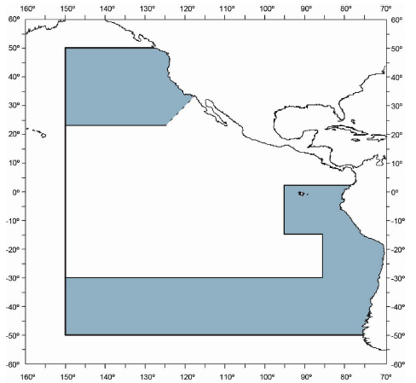
in the IATTC Convention Area

Appendix 15
Specifications for Seabird Mitigation Measures in the IATTC Convention Area

  - Tori lines

    - Minimum length: 100 m
    - Must be attached to the vessel such that it is suspended from a point a minimum of 5 m above the water at the stern on the windward side of the point where the hookline enters the water.
    - Must be attached so that the aerial extent is maintained over the sinking baited hooks.
    - Streamers must be less than 5m apart, be using swivels and long enough so that they are as close to the water as possible.
    - If the tori line is less than 150 m in length, must have a towed object attached to the end so that the aerial extent is maintained over the sinking baited hooks.
    - If two (i.e. paired) tori lines are used, the two lines must be deployed on opposing sides of the main line.

  - Tori line (light streamer)

    - Minimum length of tori line: 100 m or three times the total length of the vessel.
    - Must be attached to the vessel such that it is suspended from a point a minimum of 5 m above the water at the stern on the windward side of a point where the hookline enters the water.
    - Must be attached so that the aerial extent is maintained over the sinking baited hooks.
    - Streamers must be less than 1m apart and be 30 cm in minimum length.
    - If two (i.e. paired) tori lines are used, the two lines must be deployed on opposing sides of the main line.

- Night setting

  - No setting between local sunrise and one hour after local sunset.
  - Deck lighting to be kept to a minimum, noting requirements for safety and navigation.

- Weighted branch lines

  - Following minimum weight specifications are required:
  - Minimum weights attached to all branch lines is 45 g, with the following options:
- less than 60 g weight attached to within 1 m of the hook; or
- greater than 60 g and less than 98 g weight attached to within 3.5 ms of the hook; or
- greater than 98 g weight attached to within 4 m of the hook.

- Blue dyed bait
i. The IATTC Secretariat shall distribute a standardized color placard.
ii. All bait must be dyed to the shade shown in the placard.

- Management of offal discharge

  - Either:
- No offal discharge during setting or hauling; or
- Strategic offal discharge from the opposite side of the boat to setting/hauling to actively encourage birds away from baited hooks.

Appendix 16
Facsimile Form for Vessel Position and Fishing Operation Information
Vessel Name
(IRCS/WIN)
Registration Number of Fishing Vessel | CT －
Date of Vessel Position in GMT | Year Month Day Hour Minute
GPS Vessel Position | Latitude in North  Latitude in South | Degree Minute | Longitude in East  Longitude in West | Degree Minute
Navigation Speed and Direction | Speed | Knots | Direction | °
Movement of Fishing Vessel | □ (Fishing)  □ (Searching)  □ (Transiting )  □ (Transshipping)  □ (Drifting)  □ (Other Activities)
Person Filling the Form
※ Please fax the completed form to the Overseas Fisheries Development Council (OFDC) or fishery radio stations:

VMS Center of OFDC FAX：（02）23683536 TEL:（02）23680889
Keelung Fishery Communication Radio Station
FAX：（02）24693485 TEL:（02）24693415-7
Kaohsiung Fishery Communication Radio Station
FAX：(07)8155964 TEL:（07）8155963
Suao Fishery Communication Radio Station FAX：（03）9961942 TEL: （03）9962111
Donggang Fishery Communication Radio Station：FAX：（08）8354312 TEL:(08）8350247

Appendix 17

WCPFC EHSP Sighting Report
Date of Sighting | Time Day  Month Year | F/V ID (WIN Number)
Location of sightings | Lat: S  Long: W | Vessel Activity | - Operation  - Cruise  - Transship  - Others
Vessel Type | - Tuna Longliner  - Purse Seiner  - Carrier Vessel  - Others | Estimated Speed

Appendix 18 Designated Ports for Catching Vessels to Land or Transship in the Pacific Ocean

Country/territory | Port
Independent State of Papua New Guinea | Rabaul
 | Alotau
Japan | Shimizu
 | Yaizu
Solomon Islands | Honiara
 | Noro
French Polynesia | Tahiti
American Samoa | Pago Pago
Republic of Peru | Callao
Federated States of Micronesia | Pohnpei
 | Yap
Republic of Fiji | Suva
Republic of the Philippines | Davao
Republic of Korea | Busan
Republic of Kiribati | Tarawa
 | Kiritimati
Tuvalu | Funafuti
Republic of the Marshall Islands | Majuro
Republic of Palau | Malakal
Samoa | Apia
Domestic Ports in Taiwan | Chen-Pin Fishing Harbor in Keelung City
 | Nanfangao Fishing Port in Ilan County
 | Chienchen Fishing Harbor in Kaohsiung City
 | Siaogang Fishing Harbor in Kaohsiung City
 | Yanpu Donggang Fishing Harbor in Pingtung County
 | Hsinkang Fishing Harbor in Taitung County

Appendix 19 Information to Be Submitted for Carrier Vessels Intending to Transship in Port or at Sea

 |  | Transshipment at sea |  | Transshipment in port
 |  | National carrier vessels | Foreign carrier vessels | Foreign carrier vessels
1 | Carbon copy of vessel’s nationality certificate |  | ○ | ○
2 | Name of vessel and its registration number |  | ○ | ○
3 | Previous name(s) |  | ○ | ○
4 | Previous flag(s) |  | ○ | ○
5 | Details of vessel information in previous registrations |  | ○ | ○
6 | International radio call signs |  | ○ | ○
7 | Lloyds (LR) or International Maritime Organization (IMO) ship identification number |  | ○ | ○
8 | Type of vessel, length, gross tonnage (GT), and carrying capacity |  | ○ | ○
9 | Name and address of the owner(s) and the distant water fisheries operator(s) |  | ○ | ○
10 | Carbon copy of business registration certificate of owner(s) or distant water fisheries operator(s) |  | ○ | ○
11 | Data Network Identity (DNID) number of the vessel and the agreement of vessel position polling | ○ | ○ | ○
12 | Number of satellite phone and facsimile on board | ○ | ○ | ○
13 | Estimated transshipment period | ○ | ○
14 | Route chart | ○ | ○
15 | Whether at-sea or in-port transshipment is to be conducted. For at-sea transshipment, the carrier vessel shall, before the transshipment takes place, receive an observer at a port, and indicate the name of the port. | ○ | ○
16 | For transshipment within the WCPFC Convention Area or the transshipment in other waters of the catch taken from the WCPFC Convention Area, the fish species and amount of catches caught from respective convention areas of different international fisheries organizations shall be distinguished, and the carrier vessel shall report the information regarding the observer recognized by the WCPFC regional observer program. | ○ | ○
17 | Other designated documents as promulgated by the competent authority of the central government. | ○ | ○
18 | List of catching vessel(s) intending to conduct the transshipment | ○ | ○

Appendix 20
WCPFC TRANSSHIPMENT NOTIFICATION
Applied by □ a tuna longliner □ a carrier vessel
Name of Vessel/ WCPFC Identification Number (WIN) of the offloading vessel |  |  |  |  |  |  | Name of receiving vessel / WCPFC Identification Number (WIN) of the receiving vessel
Estimated Date of Transshipment |  |  | day month year |  |  |  | Estimated Location of Transshipment (latitude and longitude to a tenth of a degree with a margin of error of 24 nautical miles)¹
Date of Harvesting the Catch to be Transshipped |  |  | From day month year  To day month year |  |  |  | Notification to Port State Authorities before In-Port Transshipment |  |  |  | □YES  day month year  □NO否
Species ² | Product Type | Catch Transshipped (kg) |  | Catch Remaining Onboard (kg) |  | Geographic Location  WCPFC or IATTC HS/ EEZ | Species | Product Type | Catch Transshipped (kg) | Tonnage Catch Remaining Onboard (kg) |  | Geographic Location  WCPFC or IATTC HS/ EEZ
Estimated Landing Country |  |  |  |  |  |  |  |  |  | 簽 證 欄

Signature of Master Signature of Distant Water Fisheries Operator
¹In case that the location of transshipment is changed, please notify the Fisheries Agency immediately.
² The column shall be filled by the distant water fisheries operator or the captain, identifying the respective portion of the catch taken from the WCPFC Convention Area, outside the WCPFC Convention Area, or within a named exclusive economic zone.
Appendix 21
IATTC Transshipment Notification
Applied by □ a tuna longliner □ a carrier vessel
Name of Vessel |  |  |  |  |  |  | RFMO List Number of Vessel
Name of Carrier |  |  |  |  |  |  | RFMO List Number of Carrier
Estimated Date of Transshipment |  |  | day month year |  |  |  | Date of Harvesting the Catch to be Transshipped |  |  | From day month year  To day month year
Estimated Location of Transshipment |  |  |  |  |  |  | Notification to Port State Authorities before In-Port Transshipment |  |  | □YES  day month year  □NO
Product | Product Type | Catch Transshipped (kg) | Catch Remaining Onboard (kg) |  |  | Geographic Location of the Catch | Product | Product Type | Catch Transshipped (kg) | Catch Remaining Onboard (kg) | Geographic Location of the Catch
Estimated Landing Country

 |  |  |  |  | 簽 證 欄

Signature of Master Signature of Distant Water Fisheries Operator

Appendix 22
TRANSSHIPMENT NOTIFICATION FOR TUNA PURSE SEINER
Applied by □ a tuna puser seiner □ a carrier vessel
Name of Vessel/ WCPFC Identification Number (WIN) of the vessel |  |  |  |  |  | Name / WCPFC Identification Number (WIN) of the receiving vessel
Estimated Date of Transshipment |  | day month year |  |  |  | Estimated Port of Transshipment ¹
Period of Harvesting the Catch to be Transshipped |  | From day month year  To day month year |  |  |  | Notification to Port State Authorities before In-Port Transshipment |  | □YES  day month year  □NO
Species² | Geographic Location of the Catch in WCPFC  (HS)/(EEZ) |  |  | Tonnage Transshipped | Tonnage Remining Onboard | Species | Geographic Location of the Catch in WCPFC  (HS)/ (EEZ) |  | Tonnage Transshipped | Tonnage Remining Onboard
Estimated Landing Country

＊The Company/I hereby confirm that this application for transshipment is in compliance with relevant domestic regulations and measures adopted by the Western and Central Pacific Fisheries Commission. For applications for transshipments by fishing vessels owned by this company/me which have entered into fisheries cooperation with coastal States, this company/I will make such applications to the coastal States concerned in compliance with relevant conditions under such fisheries cooperation.

Signature of Master Signature of Distant Water Fisheries Operator

Note:
- In case that the location of transshipment is changed, please notify the Fisheries Agency immediately.
- The column shall be filled by the distant water fisheries operator or the captain, identifying the respective portion of the catch taken from the high seas of the WCPFC Convention Area, or within a named exclusive economic zone.
Appendix 23 WCPFC TRANSHIPMENT DECLARATION
Applied by □ a tuna longliner □ a carrier vessel
Carrier vessel  Name of vessel and radio call sign:  Country flag:  Flag state authorization number:  National Register Number:  WCPFC Identification Number(WIN): |  |  |  |  |  |  |  |  |  |  |  |  |  |  |  |  |  |  |  |  |  | Fishing vessel (Gear Longline)  Name of vessel and radio call sign:  Country flag:  Flag state authorization number:  National Register Number:  WCPFC Identification Number(WIN):
 |  | Day |  | Month |  |  | Hour |  |  | Year |  |  |  |  |  | Agent’s Name: |  |  |  |  |  | Master’s name of FV: |  |  | Master’s name of  Carrier: |  |  | WCPFC ROP Observer Name(***):
Departure |  |  |  |  |  |  |  |  |  | From
Return |  |  |  |  |  |  |  |  |  | To |  |  |  |  |  | Signature |  |  |  |  |  | Signature |  |  | Signature |  |  | Signature
Transshipment
LOCATION OF TRANSSHIPMENT |  |  |  |  |  |  | High Seas /within a EEZ( ) /Port /outside the convention area (Please circle one)
Latitude |  |  |  |  |  |  | Longitude |  |  |  |  |  |  |  |  |  |  |  |  |  | Period of Harvesting the Catch Transshipped  From day month year  To day month year
Port name |  |  |  |  |  |  | TOTAL WEIGHT IN KILOGRAMS
QUANTITY OF PRODUCT TO BE TRANSSHIPPED |  |  |  |  |  |  |  |  |  |  |  |  |  |  |  |  |  |  |  |  |  |  |  |  |  | QUANTITY OF PRODUCT ALREADY ON BOARD THE RECEIVIING VESSEL  (Tonnage)
Species(*) | Geographic  location(**) |  |  |  |  |  |  |  | Type of Product |  |  |  |  |  |  |  |  |  |  |  |  |  |  |  | Total | Species | Quantity of Product
 |  |  |  |  |  |  |  |  | whole |  |  | Gilled and Gutted |  |  | Gutted and Headed |  |  | Gilled, Gutted and Tailed |  | Gutted, Headed and Tailed |  | Gutted Only | Fillets | Shark Fins |  |  | IOTC | IATTC | ICCAT | WCPFC
Total |  |  |  |  |  |  |  |  |  |  |  |  |  |  |  |  |  |  |  |  |  |  |  |  |  | Total
Indicate the weight in kilograms or the unit used (e.g. box, basket) and the landed weight in kilograms of this unit : kilograms
(*)including not tuna species, (**)High Seas or [ ]s EEZ or Port or outside the convention area (listed separately), (***)If transshipment is effected at sea in the convention area

Catch remaining on board

Species | Processing Type | Catch Remaining Onboard (kg)

Notes:
- No need to fill for carrier vessels.
- No need to provide to the observer in case of at-sea transshipment.

Appendix 24 IATTC TRANSHIPMENT DECLARATION
Applied by □ a tuna longliner □ a carrier vessel
Carrier vessel |  |  |  |  |  |  |  |  |  |  |  |  |  |  |  |  |  | Fishing vessel
Name of vessel and radio call sign |  |  |  |  |  |  |  |  |  |  |  |  |  |  |  |  |  | Name of vessel and radio call sign
Country flag |  |  |  |  |  |  |  |  |  |  |  |  |  |  |  |  |  | Country flag
Flag state license number |  |  |  |  |  |  |  |  |  |  |  |  |  |  |  |  |  | Flag state license number
National Register Number, if available |  |  |  |  |  |  |  |  |  |  |  |  |  |  |  |  |  | National Register Number, if available
IATTC Register Number, if available |  |  |  |  |  |  |  |  |  |  |  |  |  |  |  |  |  | IATTC Register Number, if available
 | Day |  | Month |  |  | Hour |  |  | Year |  |  |  |  |  |  |  | Agent’s Name: |  |  |  |  | Master’s name of LSTV |  |  |  | Master’s name of Carrier:
Departure |  |  |  |  |  |  |  |  | From
Return |  |  |  |  |  |  |  |  | To |  |  |  |  |  |  |  | Signature |  |  |  |  | Signature |  |  |  | Signature
Transshipment
Indicate the weight in kilograms or the unit used (e.g. box, basket) and the bonded weight in kilograms of this unit : kilograms
LOCATION OF TRANSSHIPMENT: |  |  |  |  |  |  | Period of Harvesting the Catch Transshipped  From day month year To day month year
Species | Port |  |  |  |  |  | Sea |  | Type of Product
 |  |  |  |  |  |  |  |  | Whole |  |  |  | Gutted |  |  | Headed |  |  | Filleted
If transshipment effect at sea, IATTC Observer Signature:

Catch remaining on board

Species | Processing Type | Catch Remaining Onboard (kg)

Notes:
- No need to fill for carrier vessels.
- No need to provide to the observer in case of at-sea transshipment.

Appendix 25
TRANSSHIPMENT DECLARATION AND LANDING NOTIFICATION FOR TUNA PURSE SEINER
Applied by □ a tuna puser seiner □ a carrier vessel
Carrier vessel  Name of vessel and international radio call sign  Country Flag  National Register Number  WCPFC Identification Number (WIN) |  |  |  |  |  |  |  | Fishing vessel  Name of vessel and international radio call sign  Country Flag  National Register Number  WCPFC Identification Number (WIN)
Period of Harvesting the Catch Transshipped |  | From day month year  To day month year |  |  |  |  | Transshipment Time | day month hour year |  |  |  | Port of Transshipment
Fishing Area (in FAO Major Fishing Area Code): |  |  |  |  | Estimated Time of Landing: |  |  | day month hour year |  |  |  | Estimated Port of Landing
Agent’s name：  Signature： |  |  |  |  | Master’s name of FV：  Signature： |  |  |  |  | Master’s name of Carrier：  Signature：
QUANTITY OF PRODUCT TO BE TRANSHIPPED |  |  |  |  |  |  |  |  | QUANTITY OF PRODUCT ALREADY ON BOARD THE CARRIER,(Tonnage)
Species ¹ | Geographic Location of the Catch ²  (HS)/ (EEZ) |  |  | State of fish (fresh or frozen) |  | Tonnage |  |  | Species¹ |  | WCPFC |  | IATTC
 |  |  |  |  |  |  |  |  | Total
Notes:
- Including species other than tuna
- Respective catch amounts from the high seas of the WCPFC Convention Area or from a named exclusive economic zone shall be listed separately.
- In case that the transshipment declaration is not submitted concurrently with landing notification, leave the column of fishing area, estimated date of landing and estimated port of landing blank.

Catch remaining on board

Species | Processing Type | Catch Remaining Onboard (kg)

Notes:
- No need to fill for carrier vessels.

Appendix 26
Advance Notice of Landing/ Landing Declaration for Catches of Distant Water Fishing Vessels

Vessel Name: |  |  |  | CT Number: CT -
Fishing Area: |  |  |  | Fishing Period:  From yyy/mm/dd to yyy/mm/dd
□Advance Notice of Landing (please fill in column 1, 2, or 3 below) |  |  |  | □ Landing Declaration(please fill in column 4, 5, or 6 below)
1 □ Landing by a fishing vessel itself  Port of landing:  Estimated date for landing: |  |  |  | 4 □ Landing by a fishing vessel itself  Port of landing:  Starting date of landing:  Date of completion of landing:
2 □ Landing by commissioning a carrier Port of landing:
Name and registration No. in RFMO of
the carrier:
Estimated date for landing for the carrier:
5 □ Landing by commissioning a carrier Port of landing:
Name and registration No. in RFMO of
the carrier:
Starting date of landing:
Date of completion of landing:
3 □ Commissioning an airplane or container vessel to transport after landing in port by a fishing vessel  Port of consignment:  Estimated date of landing by the fishing vessel itself:  Estimated destination for the container:  Estimated date of arrival: |  |  |  | 6 □ Commissioning an airplane or container vessel to transport after landing in port by a fishing vessel  Port of consignment:  Date of landing by the fishing vessel itself:__________  Destination of the container:  Date of customs clearance of the container:___________
7 Catch Landed (Processing Types, e.g. roud fish (RD)；gilled and gutted (GG)；headed and gutted (DR)；others (please specify)
Species | Processing Type | Landing Amount | Catch Remaining  Onboard | Species | Processing Type | Landing Amount | Catch Remaining Onboard
(please fill in KG) Total KG
Notes:
- Name and Phone Number of the Assigned Fish Trading Agent:  - Name and Phone Number of the Refrigerated Plant:  - Name and Phone Number of the Processing Plant: |  |  |  | - Traded in Fish Market:  - Traded by the Fishery Operator:  - Others (please specify)
Both the Advance Notice and Declaration shall be written in duplicate, and the fishing vessel and the Fisheries Agency shall hold each copy respectively.

Signature of the captain or distant water fisheries operator: Phone Number:
Date of Submission: year month day
Appendix 27
Notification Form of Entry into or Exiting High Seas
Vessel Name |  | CT NO.
Date & time of entry into high seas (GMT)  Yr Mth Day Hour Min |  | Lat/Lon of entry into high seas  Lat. Lon.
Date & time of exiting high seas (GMT)  Yr Mth Day Hour Min |  | Lat/Lon of exiting high seas  Lat. Lon.
Note: Transshipment, bunkering, or receiving supplies on high seas are not allowed.

Appendix 28

Discard Notification of Purse Seiner Catches
Vessel Name |  |  | Flag State of The Vessel |  |  | WCPFC ID Number
Name of Master |  |  | Nationality of Master |  |  | License Number
Name of Observer |  |  | Date and Time of Set |  |  | Latitude/Longitude of Set
FAD type | □ Drifting FAD □ Anchored FAD □ Free School |  |  |  |  | The final set of a trip |  |  | □ Yes  □ No
Date and Time of Discard |  |  |  |  | Latitude/Longitude of Discard
Estimation of retained fish from that set |  | Species |  | Tonnage | Estimation of discarded fish | Species | Tonnage | Discard Reason*
 |  | SKJ |  |  |  | SKJ
 |  | BET |  |  |  | BET
 |  | YFT |  |  |  | YFT
Notes |  | (In case of the final set of a trip, a statement that no further fishing will be undertaken until the catch on board has been unloaded shall be made.)
* Codes for Discard Reasons：
“Unfit for human consumption” is defined as the follows:
Code 1: is meshed or crushed in the purse seine net;
Code 2: is damaged due to shark or whale depredation; or
Code 3: has died and spoiled in the net where a gear failure has prevented both the normal retrieval of the net and catch and efforts to release the fish alive.
The final set of a trip:
Code 4: is insufficient well space to accommodate all fish caught in that set. For Code 4, a statement that no further fishing will be undertaken until the catch on board has been unloaded shall be made in the “Notes” column.
Malfunction of fishing vessel equipment:
Code 5: serious malfunction of equipment occurs.
“Unfit for human consumption” does not include fish that
- is considered undesirable in terms of size, marketability, or species composition; or
- is spoiled or contaminated as the result of an act or omission of the crew of the fishing vessel.
I have confirmed the above-mentioned information and will receive a copy of the notification Signature of Observer：
Appendix 29

Report on Incidental Catch by Purse Seine Fishing Vessels
Vessel Name |  | Registration No. | CT －
Time and Date of Set | Date: mm dd yy  Time: hh mm | Location of Set | Longitude: Deg. Min. (E/W)  Latitude: Deg. Min. (N/S)
Steps taken to ensure safe release | Stop net roll Stop fishing operation Other_____________
Species and number of incidental catch | Whale: species name__________, number of catch ____; species name__________, number of catch ____; species name__________, number of catch ____
 | Dolphin: species name___________, number of catch____; species name___________, number of catch____; species name___________, number of catch____
 | Whale Shark: number of catch_________
 | Sea turtle: species name___________, number of catch____; species name___________, number of catch____; species name___________, number of catch____
 | Other: species name___________, number of catch____; species name___________, number of catch____; species name___________, number of catch____
Details on the species caught incidentally  (if known) |  | Life status after release |  | Alive; Dead

Appendix 30 The conversion factors between the weights of processed fish and round fish

Formula: round weight =
the weight of processed fish × the conversion factor

Species | Processing Types | Conversion factors
Bigeye tuna | Gilled and gutted (GG) | 1.14
 | Headed and gutted (DR) | 1.23
Yellowfin tuna | Gilled and gutted (GG) | 1.11
 | Headed and gutted (DR) | 1.23
Swordfish | Gilled and gutted (GG) | 1.14
 | Headed and gutted (DR) | 1.21
Blue marlin | Headed and gutted (DR) | 1.15
Striped marlin | Headed and gutted (DR) | 1.26
Bluefin tuna | Gilled and gutted (GG) | 1.16
Sharks | Headed and gutted (DR) | 1.54
 | Headed, gutted, retained both fin and trunk | 2.40

