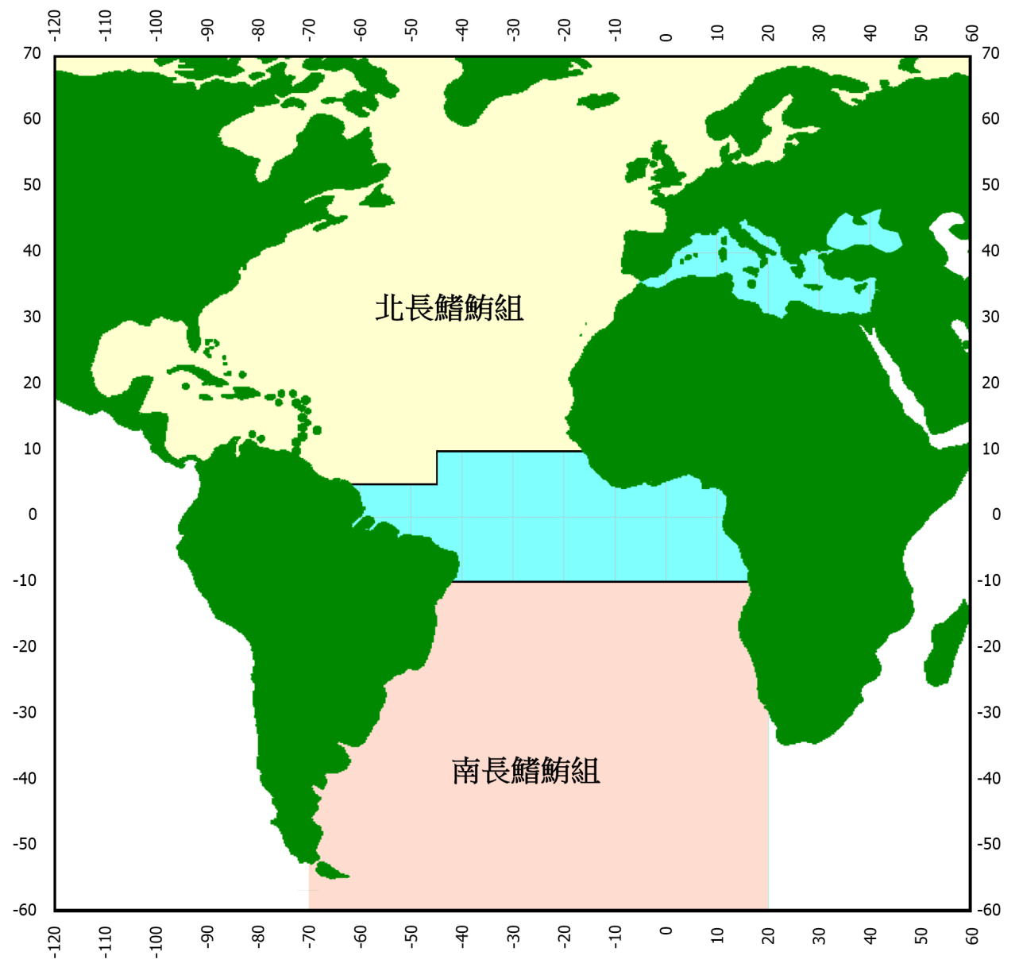
Appendix 3: Fishing areas of the north albacore tuna group and south albacore tuna group

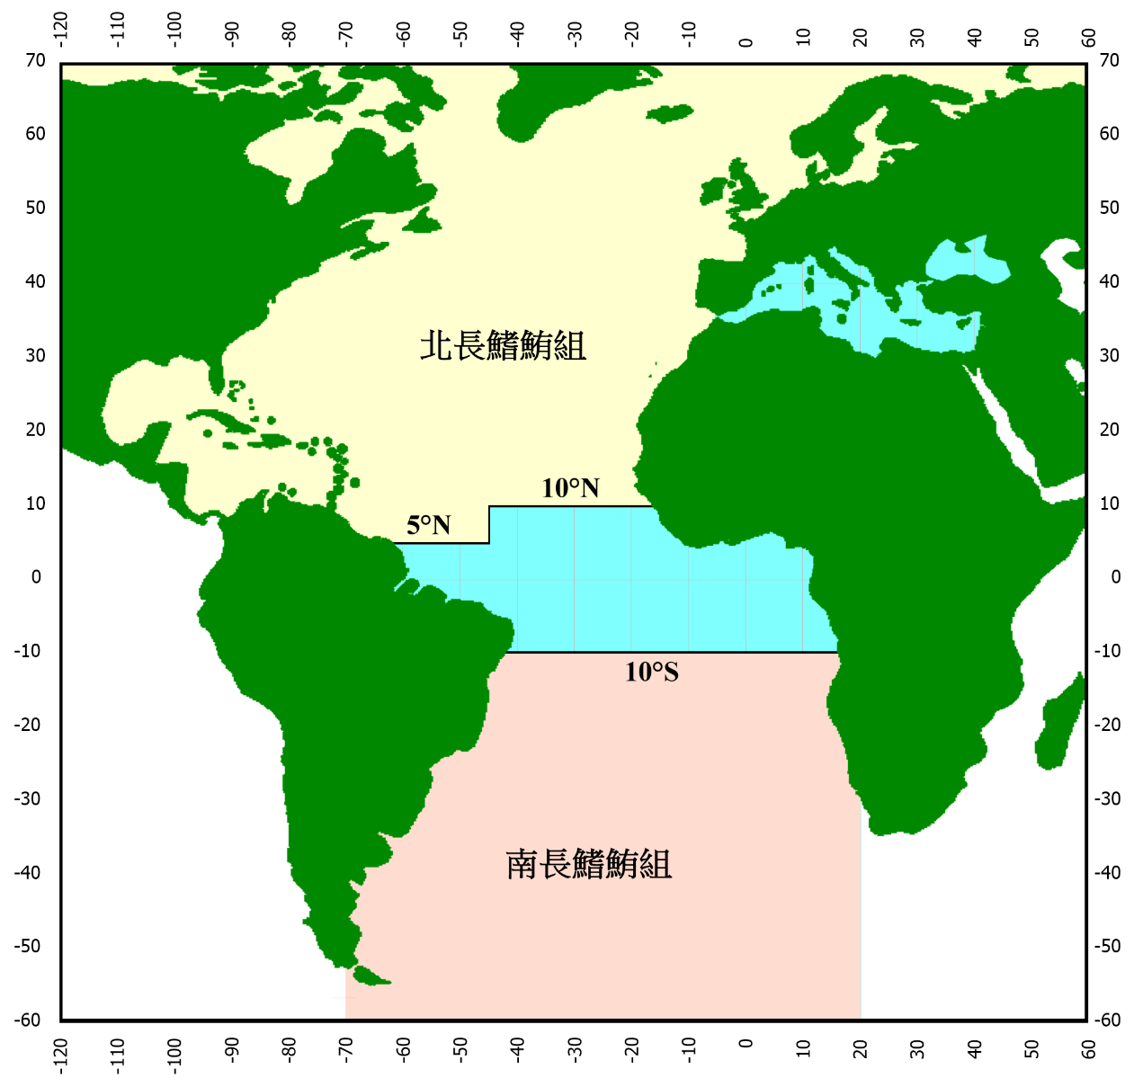
South albacore tuna group

North albacore tuna group

