Appendix 2: The fishing area of the bigeye tuna group

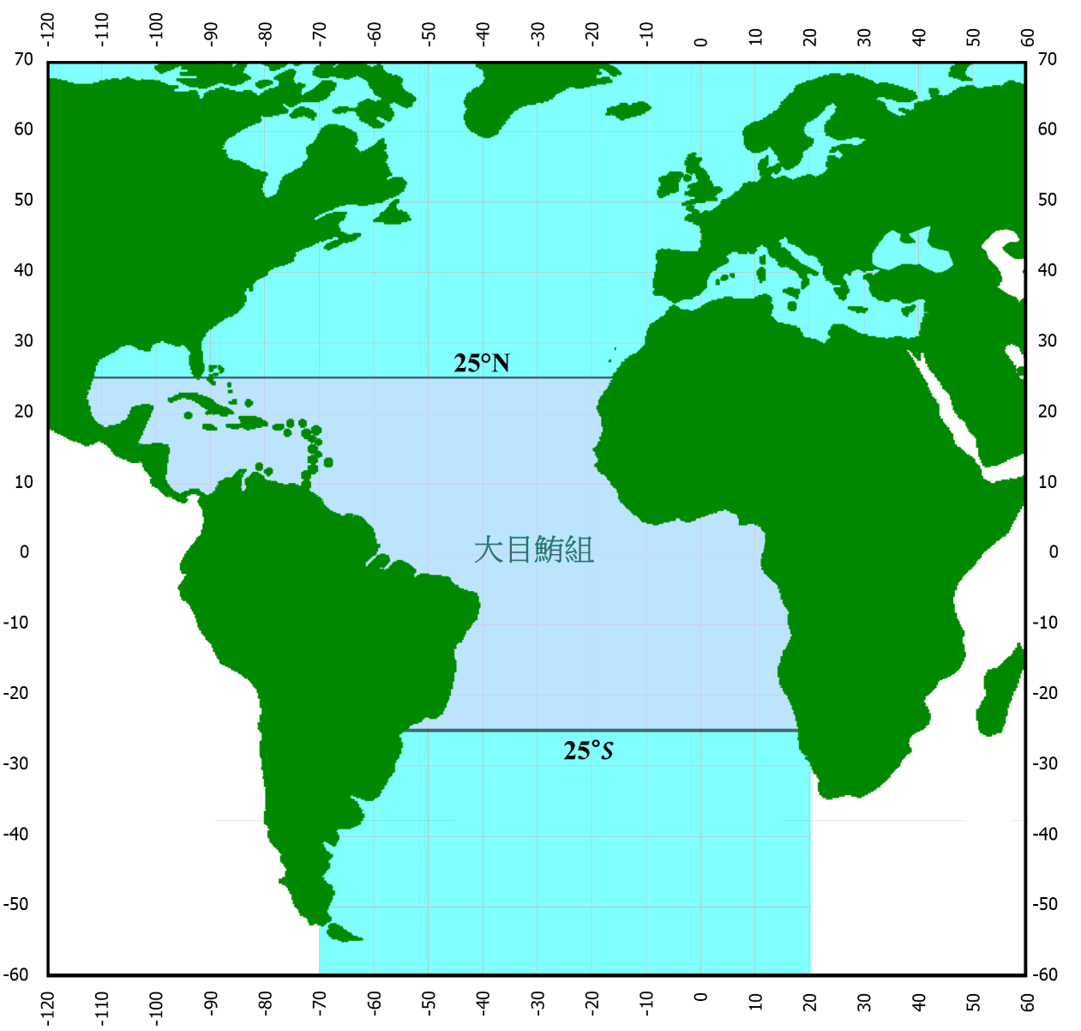
Bigeye tuna group

