Appendix 3-1 Fishing areas of the eastern Atlantic bluefin tuna group
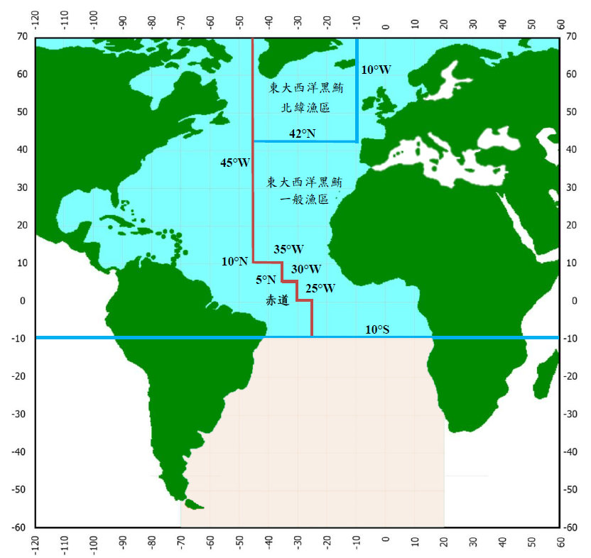
Equator
General fishing area
North latitude fishing area

