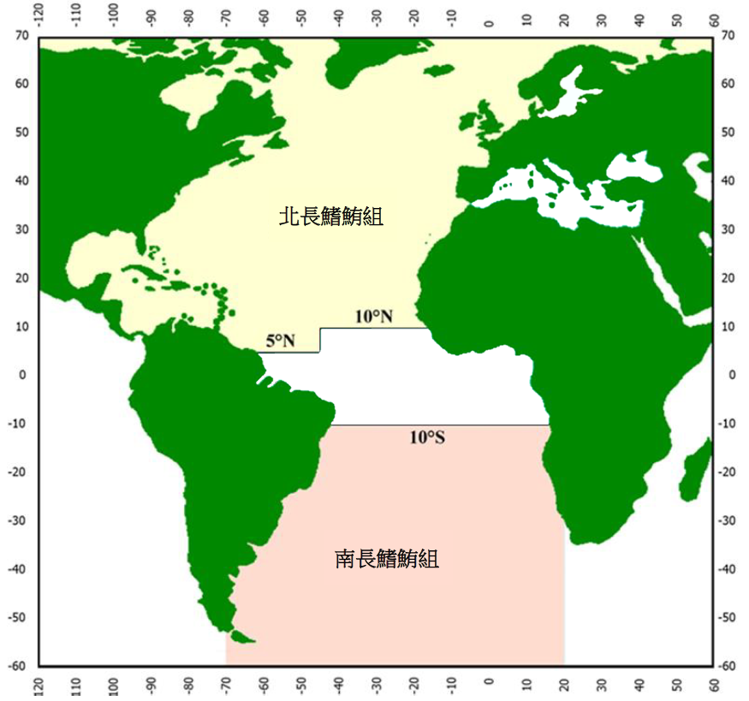
Appendix 3:
Fishing areas of the north albacore tuna group and south albacore tuna group
South albacore tuna group
North albacore tuna group

