Appendix 1 The area of the Indian Ocean

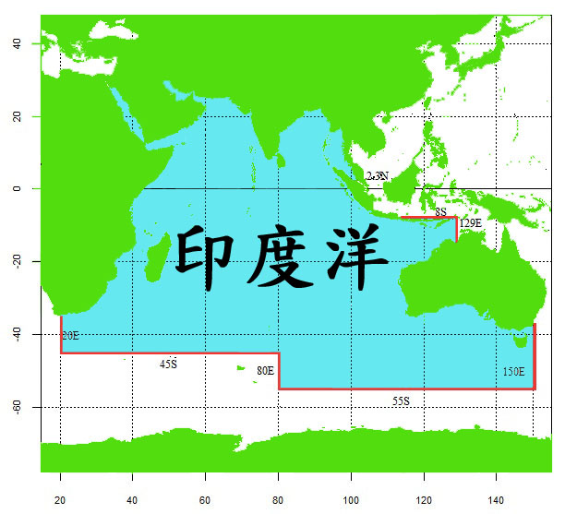
The Indian Ocean

Appendix 1-1 The area of the Southern Indian Ocean Fisheries Agreement
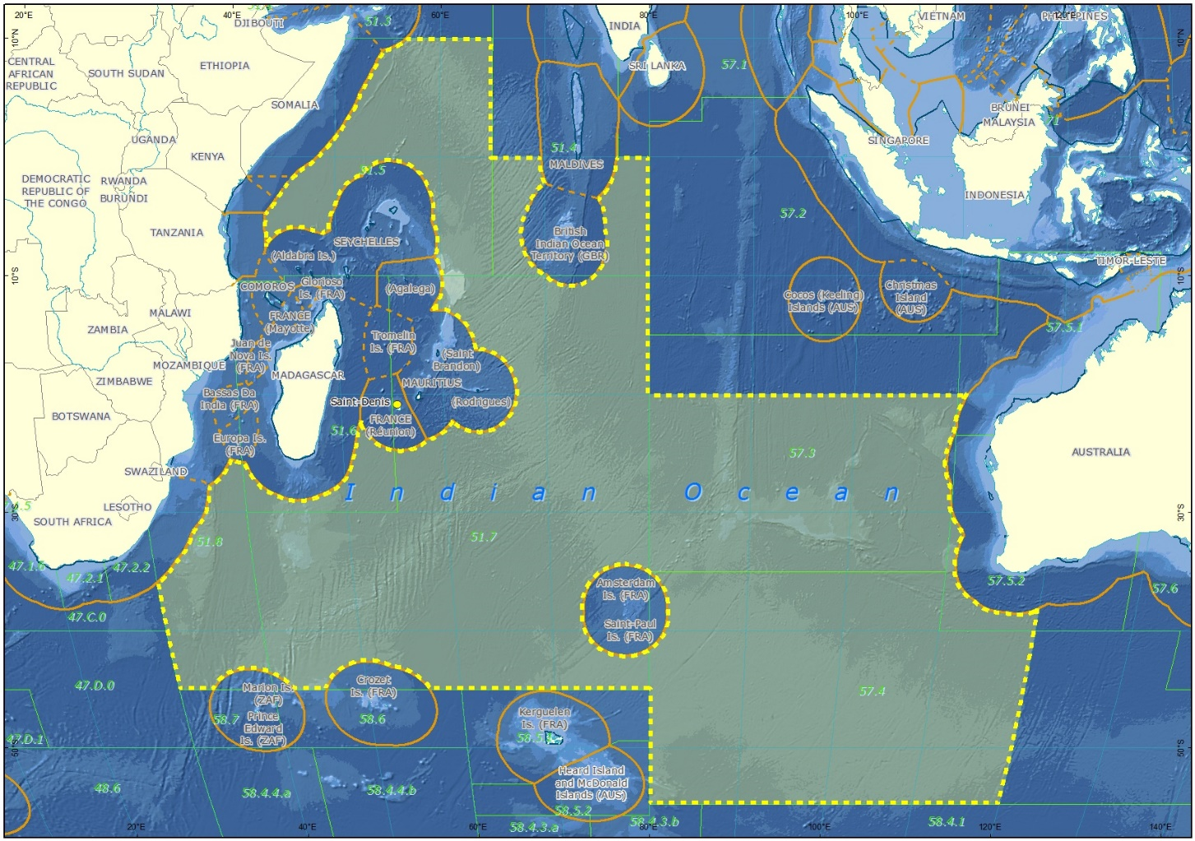

Appendix 2 The bigeye tuna fishing area
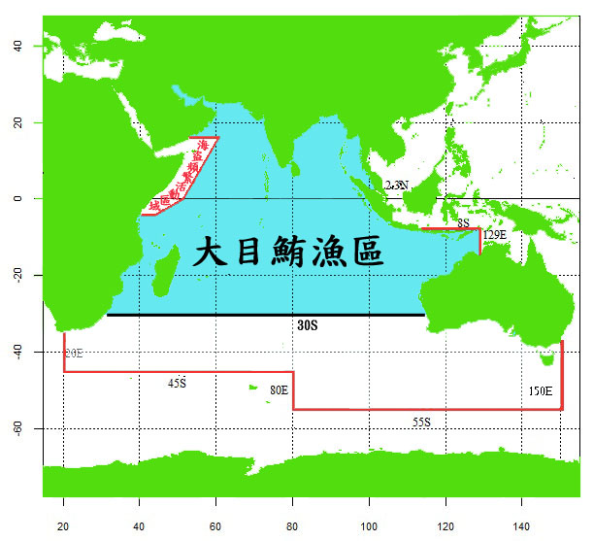
The The bigeye tuna fishing area
high risk area of piracy

Note: the high risk area of piracy is bounded by the following lines: from the east coast of Kenya due east along the 4°S to its intersection with 44°E; thence due northeast to the intersection between the equator and the 49°E; thence to the intersection between the 15°N and the 61°E; thence due west along the 15°N to the west off the east coast of Yemen

Appendix 3 The oilfish fishing area

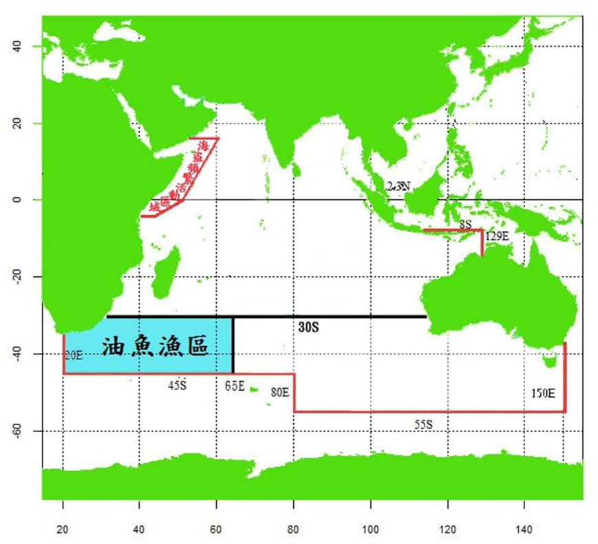
The The oilfish fishing area
high risk area of piracy

Appendix 4 The albacore tuna fishing area
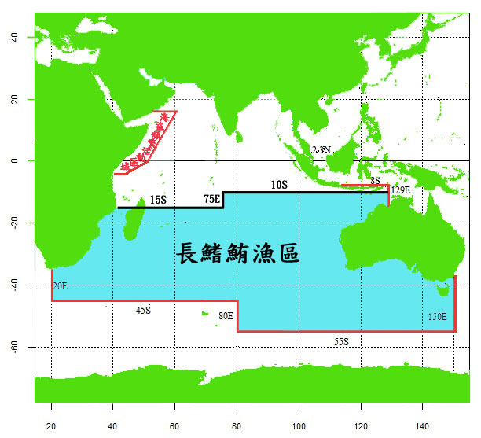
high risk area of piracy
The The albacore tuna fishing area

Appendix 5 The fishing area for small scale longliners
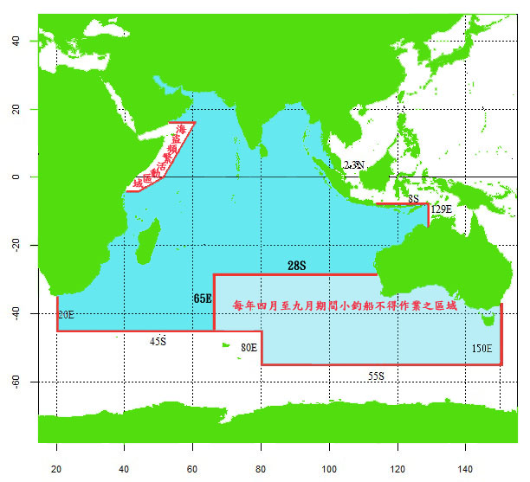
The area where small scale longliners shall not fish from April to September every year
high risk area of piracy

Note: the high risk area of piracy is bounded by the following lines: from the east coast of Kenya due east along the 4°S to its intersection with 44°E; thence due northeast to the intersection between the equator and the 49°E; thence to the intersection between the 15°N and the 61°E; thence due west along the 15°N to the west off the east coast of Yemen

Appendix 6
Application Form for Large Scale Longliners
Registration Number of Fishing Vessel | CT － |  | Vessel Name in Chinese
Registration Number of Fishing Vessel |  |  | Vessel Name in English
Distant Water Fisheries Operator | Name of Individual or Company
Distant Water Fisheries Operator | Legal Representative
Distant Water Fisheries Operator | Contact Person
Distant Water Fisheries Operator | Contact Address
Distant Water Fisheries Operator | Contact Telephone Number
Group of Fishing Vessel | □ Bigeye Tuna Group  □ Albacore Tuna Group |  |  | Ultra-low temperature devices |  |  | □Yes  □No
Satellite Communication and VMS equipment | VMS | □INMARSAT-C |  | Type
Satellite Communication and VMS equipment | VMS | □INMARSAT-IDP
Satellite Communication and VMS equipment | VMS | ALC number:
Satellite Communication and VMS equipment | Satellite Telephone Number
Total volume of fish holds | ___________ cubic meters

Name of Applicant: (Signature or Stamp)
To Ministrt of Agriculture
Date:

Appendix 7
Application Form for Small Scale Longliners

Registration Number of Fishing Vessel | CT － |  | Vessel Name in Chinese
Registration Number of Fishing Vessel |  |  | Vessel Name in English
Distant Water  Fisheries Operator | Name of Individual
Distant Water  Fisheries Operator | Name of Company
Distant Water  Fisheries Operator | The Legal Representative
Distant Water  Fisheries Operator | Contact Person
Distant Water  Fisheries Operator | Contact Address
Distant Water  Fisheries Operator | Contact Telephone No.
Group of Fishing Vessel | □Frozen Yellowfin Tuna Group  □General Group |  |  | Type of Storage |  | □Chilled  □Frozen  □Ultra-low temperature（below -50℃）
Target Species | Yellowfin Tuna Albacore Tuna Sharks  Mahi Mahi Billfishes Others (Please specify species)
 | VMS | □ INMARSAT-C |  | Type
 | VMS | □INMARSAT-IDP
 | VMS | □IRIDIUM
 | VMS | ALC number：
 | Satellite Telephone No.
Total volume of fish holds | ___________ cubic meters

Name of Applicant : (Signature or Stamp)
To Ministry of Agriculture:
Date:

Appendix 8
Application Form for Carrier Vessels of the Republic of China
Registration Number of Fishing Vessel | CT － |  | Vessel Name in Chinese
Registration Number of Fishing Vessel |  |  | Vessel Name in English
Distant Water Fisheries Operator | Name of Company
Distant Water Fisheries Operator | Legal Representative
Distant Water Fisheries Operator | Contact Person
Distant Water Fisheries Operator | Contact Address
Distant Water Fisheries Operator | Contact Telephone Number
Satellite Communication and VMS equipment | VMS | □IRIDIUM |  | Type
Satellite Communication and VMS equipment | VMS | □INMARSAT-C
Satellite Communication and VMS equipment | VMS | □INMARSAT-IDP
Satellite Communication and VMS equipment | VMS | ALC number:
Satellite Communication and VMS equipment | Satellite Telephone Number | (required)
Operation Area | - Pacific Ocean □Indian Ocean □Atlantic Ocean

Name of Applicant: (Signature or Stamp)
To Ministry of Agriculture
Date:

Appendix 8-1 Application Format for Oil Fish Distant Water Fisheries Permits
Information on fishing vessel:
Registration number | CT___-__________ | IMO number
Registration number | CT___-__________ | IRCS
Chinese vessel name |  | English vessel name
Port of registry |  | Previous vessel name | □No  □Yes:_______________
GT |  | LOA | (meter)
Main engine horse power | (KW) | Fish hold volume | (cubic meter)
VMS | □IRIDIUM | Type
VMS | □INMARSAT-C | Type
VMS | □INMARSAT-IDP | Type
Satellite communication | Brand
Satellite communication | Setellite Tel No.
□ Exectronic files of 4 color photos of the vessel have been provided |  | □ Electronic file of the vessel layout has been provided

Information on distant water fisheries operator:
Name of individual or company
Legal representative
Contact person
Contact add
Tel No.

Fishing period:
from_______ _(Date/Month/Year) to __________ (Date/Month/Year)

Appendix 9
Specification of Width, Height and Color of Characters for
Vessel Markings

I. Chinese Vessel Name
1. Height Standard of Characters
GT of Vessel |  | Minimum Length
20 GT and above and less than 100 GT |  | 25 cm
100 GT and above and less than 1,000 GT |  | 30 cm
1,000 GT and above |  | 35 cm
2. Color of Characters
Ground Color of Fishing Vessel | Color of Characters
Dark Color | White
Bright Color | Black

II. English Vessel Name and CT Number
1. Height Standard of Characters
GT of Vessel |  | Minimum Length
20 GT and above and less than 100 GT |  | 15 cm
100 GT and above and less than 1,000 GT |  | 20 cm
1,000 GT and above |  | 25 cm
2. Color of Characters
Ground Color of Fishing Vessel | Color of Characters
Dark Color | White
Bright Color | Black

III. IRCS
- Height Standard of Character
Position of Marking | Vessel Length Overall |  |  | Minimum Length
Both Sides of the Vessel | 25 meters and above |  |  | 1 meter
Both Sides of the Vessel | 20 meters and above and less than 25 meters |  |  | 80 cm
Both Sides of the Vessel | 15 meters and above and less than 20 meters |  |  | 60 cm
Both Sides of the Vessel | 12 meters and above and less than 15 meters |  |  | 40 cm
Both Sides of the Vessel | 5 meters and above and less than 12 meters |  |  | 30 cm
Both Sides of the Vessel | Less than 5 meters |  |  | 10 cm
Deck | 5 meters and above |  |  | 30 cm
- Width Standard
Marking Items |  |  | The Proportion of Marking Items to the height
Width of Hyphen |  |  | Half
Stroke Width of Characters or Hyphen |  |  | One-sixth
Space between Characters |  |  | One-sixth and above and less than one-fouth
Adjacent Space of Characters with  Hypotenuse Form (such as Ａ,Ｖ) |  |  | One-tenth and above and less than one-eighth
- Color of Characters
Ground Color of Fishing Vessel |  | Color of Characters
Dark Color |  | White
Bright Color |  | Black

Appendix 10
De-hooker (left) and Scoop net (right)

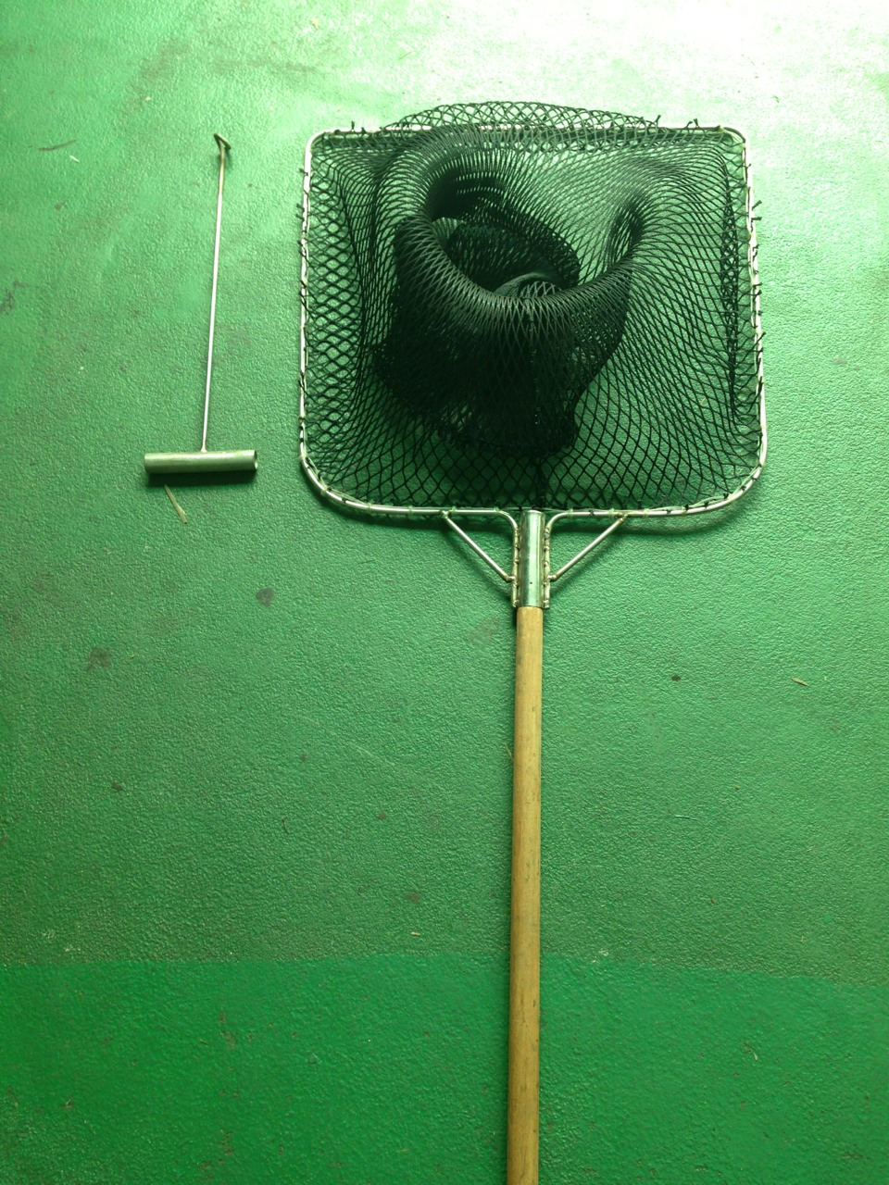

Appendix 12
Facsimile Form for Vessel Position and Fishing Operation Information
Vessel Name
(IRCS/WIN)
Registration Number of Fishing Vessel | CT －
Date of Vessel Position in GMT | Year Month Day Hour Minute
GPS Vessel Position | Latitude in North  Latitude in South | Degree Minute | Longitude in East  Longitude in West | Degree  Minute
Navigation Speed and Direction | Speed | Knots | Direction | °
Movement of Fishing Vessel | □ (Fishing)  □ (Searching)  □ (Transiting )  □ (Transshipping)  □ (Drifting)  □ (Other Activities)
Person Filling the Form
(operator)
- Please affix the official company stamp and the authorized signatory’s seal, if the operator is a company.
- Please fax the completed form to the Fisheries Monitoring Center (FMC) of the Fisheries Agency or fishery radio stations:
FMC FAX：（02）23012801、（02）23328326 TEL:（02）23835782
Kaohsiung Fishery Communication Radio Station FAX：(07)8155964 TEL:（07）8155963
Donggang Fishery Communication Radio Station FAX：（08）8354312 TEL:(08）8350247

Appendix 13

Designated Ports for Tuna Longline Fishing Vessels to Land or Transship

Country/Territory | Port
Malaysia | Penang
Republic of South Africa | Durban
Republic of South Africa | Cape Town
Kingdom of Thailand | Phuket
Kingdom of Thailand | Bangkok
Republic of Seychelles | Victoria
Republic of Mauritius | Port Louis
Republic of Singapore | Singapore
Democratic Socialist Republic of Sri Lanka | Colombo
Repubic of China | Chen-Pin Fishing Harbor in Keelung City
Repubic of China | Nanfangao Fishing Port in Ilan County
Repubic of China | Chienchen Fishing Harbor in Kaohsiung City
Repubic of China | Siaogang Linhai New Residential Quarter Fishing Harbor in Kaohsiung City
Repubic of China | Cijin Fishing Harbor in Kaohsiung City
Repubic of China | Wharf No. 41 of Kaohsiung Port
Repubic of China | Yanpu Donggang Fishing Harbor in Pingtung County
Repubic of China | Hsinkang Fishing Harbor in Taitung County

Appendix 14
Information to Be Submitted for Carrier Vessels Intending to Transship in Port or at Sea

 |  | Transshipment at sea |  | Transshipment in port
 |  | National carrier vessels | Foreign carrier vessels | Foreign carrier vessels
1 | Carbon copy of vessel’s nationality certificate |  | ○ | ○
2 | Name of vessel and its registration number |  | ○ | ○
3 | Previous name(s) |  | ○ | ○
4 | Previous flag(s) |  | ○ | ○
5 | Details of vessel information in previous registrations |  | ○ | ○
6 | International radio call signs |  | ○ | ○
7 | International Maritime Organization (IMO) ship identification number |  | ○ | ○
8 | Type of vessel, length, gross tonnage (GT), and carrying capacity |  | ○ | ○
9 | Name and address of the owner(s) and the distant water fisheries operator(s) |  | ○ | ○
10 | Carbon copy of business registration certificate of owner(s) or distant water fisheries operator(s) |  | ○ | ○
11 | Number of satellite phone and facsimile on board | ○ | ○ | ○
12 | Estimated transshipment period | ○ | ○
13 | Route chart | ○ | ○
14 | Whether at-sea or in-port transshipment is to be conducted. For at-sea transshipment, the carrier vessel shall, before the transshipment takes place, receive an observer at a port, and indicate the name of the port. | ○ | ○
15 | List of tuna longline fishing vessel(s) intending to conduct the transshipment | ○ | ○
16 | Other designated documents as promulgated by the competent authority of the central government. | ○ | ○

Appendix 15
TRANSSHIPMENT NOTIFICATION
Notification for Taiwan Flagged Vessels to Apply for Transshipment
Applied by □ a tuna longliner □ a carrier vessel
Name of Vessel |  |  |  |  |  |  | RFMO List Number of Vessel
Name of Carrier |  |  |  |  |  |  | RFMO List Number of Carrier
Estimated Date for Transshipment | day month year |  |  |  |  |  | Date of Harvesting the Catch to be Transshipped |  |  | From day month year  To day month year
Estimated Location for Transshipment |  |  |  |  |  |  | Notification to Port State Authorities before In-Port Transshipment |  |  | □YES  day month year  □NO
Product |  |  | Type of Product | Tonnage |  |  | Product | Type of Product | Tonnage
Estimated Landing Country |  |  |  |  | The captain and the distant water fisheries operator shall carefully read the following content and click:  - The captain has checked and confirmed that the vessel name (Chinese and English), CT number, and IRCS marked on the vessel are correct, clear and identifiable. In case of any vessel marking infraction reported by IOTC observers for this at-sea transshipment, punishment(s) by the Ministry of Agriculture will be accepted.  - The operator has confirmed that the captain checked and confirmed that the vessel markings are in compliance with Article 16 to 18 of the Regulations for Tuna Longline Fishing Vessels Proceeding to the Indian Ocean for Fishing Operation. In case of any vessel marking infraction reported by IOTC observers for this at-sea transshipment, punishment(s) by the Ministry of Agriculture will be accepted.
Taiwan Tuna Association |  |  |  |  |  | 簽 證 欄

Signature of Master Signature of Distant Water Fisheries Operator

Appendix 16
IOTC Transshipment Declaration

IOTC Transhipment declaration
Carrier Vessel | Fishing Vessel
Name of the Vessel and Radio Call Sign:  Flag:  IMO number:  Flag State license number:  National Register Number, if available:  IOTC Register Number, if available: | Name of the Vessel and Radio Call Sign:  Flag:  IMO number:  Flag State license number:  National Register Number, if available:  IOTC Register Number, if available:
Applied by □Fishing vessel / □ Carrier Vessel
Date of Harvesting the Catch Transshipped: From To
Day Month Hour Year |2_|0_|__|__| Agent’s name: Master’s name of LSTV: Master’s name of Carrier:
Departure |__|__| |__|__| |__|__| from |__________|
Return |__|__| |__|__| |__|__| to |__________| Signature: Signature: Signature:
Transhipment |__|__| |__|__| |__|__| |__________|
For the purpose of completing this Transshipment Declaration, UTC should be used to indicate the time and date of the transshipment.
Indicate the weight in kilograms or the unit used (e.g. box, basket) and the landed weight in kilograms of this unit: |____________| kilograms
LOCATION OF TRANSHIPMENT
Species | Port |  | Sea | Type of product
 |  |  |  | Whole | Gutted | Headed | Filleted
If transshipment effected at sea, IOTC Observer Name and Signature:

Catch Retained Onboard (No need to fill for Carrier Vessel)
Species | Type | Catch Retained Onboard(kg)

Appendix 16-1
IOTC SUPPLY DECLARATION
Carrier (supply donor) Vessel: |  | Receiving vessel:
Name: |  | Name:
IOTC Register No. |  | IOTC Register No.  (24 m or over)
National registration number
(less than 24 m or non-IOTC vessel)

IMO number |  | IMO number
International Radio Call Sign |  | International Radio Call Sign
Current Flag: |  | Current Flag:
Date (indicated in UTC)*

Latitude

Longitude

Goods supplied: |  | remarks (if any)
- Fuel | ☐
- Bait | ☐
- Victuals | ☐
- Spare parts | ☐
- Medical supplies | ☐
- Passengers/Crew | ☐
- Other (specify) | ☐
* For the purpose of completing this Supply Declaration, UTC should be used to indicate the time and date of the supply.

Appendix 17

Advance Notice of Landing/ Landing Declaration for Catches of Distant Water Fishing Vessels

Vessel Name: |  |  |  | CT Number: CT -
Fishing Area: |  |  |  | Fishing Period:  From yyy/mm/dd to yyy/mm/dd
□Advance Notice of Landing (please fill in column 1, 2, or 3 below) |  |  |  | □ Landing Declaration(please fill in column 4, 5, or 6 below)
1 □ Landing by a fishing vessel itself  Port of landing:  Estimated date for landing: |  |  |  | 4 □ Landing by a fishing vessel itself  Port of landing:  Starting date of landing:  Date of completion of landing:
2 □ Landing by commissioning a carrier Port of landing:
Name and registration No. in RFMO of
the carrier:
Estimated date for landing for the carrier:
5 □ Landing by commissioning a carrier Port of landing:
Name and registration No. in RFMO of
the carrier:
Starting date of landing:
Date of completion of landing:_________
3 □ Commissioning a container vessel or airplane to transport after landing in port by a fishing vessel  Port of consignment:  Estiamted date of landing for the fishing vessel itself:  Estimated destination for the container:  Estimated date of arrival: |  |  |  | 6 □ Commissioning a container vessel or airplane to transport after landing in port by a fishing vessel  Port of consignment:  Date of landing by the fishing vessel itself:  Destination of the container：_____________  Date of customs clearance of the container:
7 Catch Landed (Processing Types, e.g. roud fish (RD); gilled and gutted (GG); headed and gutted (DR); others (please specify)
Species | Processing Type | Landing Amount | Catch Remaining  Onboard | Species | Processing Type | Landing Amount | Catch Remaining Onboard
(please fill in KG) Total KG
Notes:
- Name and Phone Number of the Assigned Fish Trading Agent:  - Name and Phone Number of the Refrigerated Plant:  - Name and Phone Number of the Processing Plant: |  |  |  | - Traded in Fish Market:  - Traded by the Fishery Operator:  - Others (please specify)
Both the Advance Notice and Declaration shall be written in duplicate, and the fishing vessel and the Fisheries Agency shall hold each copy respectively.

Signature of the captain or distant water fisheries operator: Phone Number:
Date of Submission: year month day

Appendix 17-1

List of Deep Sea Shark Species

學名 | 中文名
Apristurus indicus | 印度篦鯊
Bythaelurus tenuicephalus | 深海溝鯊類
Bythaelurus bachi | 深海溝鯊類
Centroscymnus coelolepis | 腔鱗荊鯊
Centroselachus crepidater | 長吻荊鯊
Deania calceus | 喙吻田氏鯊
Bathyraja tunae | 滕氏深海鰩
Etmopterus pusillus | 小烏鯊
Etmopterus viator | 多椎烏鯊
Etmopterus alphus | 烏鯊類
Etmopterus bigelowi | 烏鯊類
Centrophorus granulosus | 顆粒刺鯊（大西洋刺鯊）
Centrophorus squamosus | 葉鱗刺鯊
Centrophorus uyato | 同齒刺鯊
Harriotta raleighana | 扁吻銀鮫
Chlamydoselachus anguineus | 皺腮類
Hexanchus nakamurai | 中村氏六腮鯊
Mitsukurina owstoni | 歐式尖吻鯊
Squalus mitsukurii | 長吻角鯊
Rhinochimaera africana | 非洲長吻銀鮫
Deania quadrispinosa | 四棘田氏鯊
Deania profundorum | 深水田氏鯊
Dalatias licha | 鎧鯊
Zameus squamulosus | 鱗睡鯊
Somniosus antarcticus | 南極睡鯊
Scymnodon macracanthus | 大刺荊鯊
Chimaera buccanigella | 銀鮫類
Chimaera didierae | 銀鮫類
Chimaera willwatchi | 銀鮫類

Appendix 17-2
SIOFA At-Sea Transshipment Prior Notification

The following information shall be provided to the competent authority 7 days before the estimated transshipment date, and provided again 24 hours before the estimated transshipment date.
2 submissions shall be made in total
□ 1st submission: 7 days before the estimated transshipment date
□ 2nd submission: 24 hours before the estimated transshipment date
I. DETAILS OF THE NOTIFYING VESSEL
Vessel that made this notification is a Unloading Vessel / Receiving Vessel (strike out as appropriate)
II. DETAILS OF THE UNLOADING FISHING VESSEL
Name of Vessel
Vessel Flag CCP | TWN
IMO Number
Registration Number | CT -
Radio Call Sign
Vessel Owner and/or Company Information | Name：  Address：  Email：  Phone Number：
Vessel Contact Information | Master Name：  Nationality：  Address：  Email：  Phone Number：
III. DETAILS OF THE RECEIVING FISHING VESSEL
Name of Vessel
Vessel Flag CCP | TWN
IMO Number
Registration Number | CT -
Radio Call Sign
Vessel Owner / Company Information | Name：  Address：  Email：  Phone Number：
Vessel Contact Information | Master Name：  Nationality：  Address：  Email：  Phone Number：
IV. DETAILS OF TRANSSHIPMENT
Transshipment Authorization Identifier, if any | NA
Transshipment Authorisation Issued by | Fisheries Agency, Ministry of Agriculture, Taiwan  Email：taiwan-siofa@ms1.fa.gov.tw
Transshipment Authorisation Validity Period | (Y) (M) (D) ~ (Y) (M) (D)  （Please fill in 11 days calculated from the estimated transshipment date.）
Estimated Date of Transshipment | (Y) (M) (D)  （Please fill in the estimated transshipment date）
Estimated Start Time of Transshipment | UTC： (H) (M)
Estimated End time of Transshipment | UTC： (H) (M)
Estimated Location of Transshipment | (Decimal latitude/longitude of the estimated transshipment location, to 2 decimal places)
Fishery Resources to be Transshipped
Quantities to be Transshipped
Species |  | Oilfish
Catch Area |  | FAO 51、FAO 57
Weight (in kilograms) |  | (KG)
Product Form |  | Frozen
Number of Units |  | NA
Net Weight of a Unit (in kilograms) |  | NA

Appendix 17-3

SIOFA TRANSSHIPMENT AT SEA/ IN PORT DECLARATION

In port (strike out as appropriate) |  | (Y) / (N) |  |  | Name of Port |  |  |  |  | Port State
At Sea (strike out as appropriate) |  | (Y) / (N) |  |  | Latitude/Longitude |  | (In decimal format to 2 decimal places)
Declaring Vessel  (strike out as appropriate) |  | (Unloading Vessel ) / (Receiving Vessel)
Name of Unloading Vessel |  |  |  |  |  |  | Name of Receiving Vessel
IMO number of Unloading Vessel |  |  |  |  |  |  | IMO number of Receiving Vessel
IRCS of Unloading Vessel |  |  |  |  |  |  | IRCS of Receiving Vessel
External Identification of  Unloading Vessel |  | CT - |  |  |  |  | External Identification of Receiving Vessel |  |  | CT -
Flag CCP of Unloading Vessel |  | TWN |  |  |  |  | Flag of Receiving Vessel |  |  | TWN
Transshipment Authorization Identifier |  | Order No. Nung-yu-tzu:____________  （Fill in the Order No. approving the transshipment notification） |  |  |  |  | Transshipment Authorization Issued by |  |  | Fisheries Agency, Ministry of Agriculture, Taiwan  Email：taiwan-siofa@ms1.fa.gov.tw
Start of Transshipment Operation |  | (Y) (M) (D) |  |  |  |  | From (time: hour/minutes, UTC) |  |  | UTC： (H) (M)
End of Transshipment Operation |  | (Y) (M) (D) |  |  |  |  | To (time: hour/minutes, UTC) |  |  | UTC： (H) (M)
Master’s Name &  Nationality |  |  | Observer’s Name &  Nationality |  |  |  |  | Master’s Signature |  |  |  | Date
TRANSSHIPPED FISHERY RESSOURCES
Species  (FAO 3-alpha species code/group code/scientific name) | Catch Area (s)  (RFMO/geographical location/FAO Statistical Area) |  |  | Product Process/Presentation Form |  | Product Preservation Form |  |  | No. Units: |  | Weight  per Unit |  |  | TOTAL Weight  (Kg)
OIL | SIOFA Area、  FAO 51、57 |  |  | ▓ (RD)  □ (DR)  □ (OTH)：  (click as appropriate) |  | Frozen |  |  | NA |  | NA
LEC | SIOFA Area、  FAO 51、57 |  |  | ▓ (RD)  □ (DR)  □ (OTH)：  (click as appropriate) |  | Frozen |  |  | NA |  | NA
FISHERY RESSOURCES REMAINING ON BOARD AFTER TRANSSHIPMENT
Species  (FAO 3-alpha species code/group code/scientific name) | Catch Area (s)  (RFMO/geographical location/FAO Statistical Area) |  |  | Product Process/Presentation Form |  | Product Preservation Form |  |  | No. Units: |  | Weight  per Unit |  |  | TOTAL Weight  (Kg)
OIL | SIOFA Area、  FAO 51、57 |  |  | ▓ (RD)  □ (DR)  □ (OTH)：  (click as appropriate) |  | Frozen |  |  | NA |  | NA
LEC | SIOFA Area、  FAO 51、57 |  |  | ▓ (RD)  □ (DR)  □ (OTH)：  (click as appropriate) |  | Frozen |  |  | NA |  | NA

Appendix 17-4

Notification Form for Fishing Vessels Entry to and Exit from the Agreement Area

Information required
Vessel name
Entry or exit
IMO number, if applicable
Radio call sign
Vessel flag State
Latitude
Longitude
Date of entry or exit
Time of entry or exit in UTC
Activity in the Agreement Area (intended activity on entry OR activity carried out prior to exit) | Fishing (species), transiting or transhipping
Heading (optional)
Vessel heading when entering OR exiting the area (from 0° to 359°)

Appendix 17-5

SIOFA TRANSFER AT SEA NOTIFICATION

The following Information shall be provided to the competent authority of the declaring vessel 24 hours in advance of a transfer at sea.
I.、II. DETAILS OF THE DECLARING VESSEL AND THE OTHER VESSEL
 | Declaring Vessel | The Other Vessel
Name of Vessel
Registration Number
Radio Call Sign
Vessel Flag
IMO Number
Master’s Name and Nationality
III. DETAILS OF TRANSFER
Estimated Date of Transfer | UTC： (YYYY) (MM) (DD)
Estimated Time of Transfer | UTC： (HH) (MM)
Estimated Location of Transfer | Decimal latitude/longitude of the estimated transfer location, to two (2) decimal places.
Type and Quantity Unloaded and Received
The declaring vessel is a □ (received) / □ (unloaded) vessel (please click as appropriate)
- Fuel | Liters
- Crew | number
- Gear | number
- Supplies | (Food) Kilograms
- Supplies | (Baits) Tonnes
- Supplies | (Other) (specify)
- Other
IV. SIGNATURE
Name of Master

Appendix 17-6
SIOFA TRANSFER AT SEA DECLARATION

The following Information shall be provided to the competent authority of the declaring vessel within 24 hours following a transfer at sea.
I.、II. DETAILS OF THE DECLARING VESSEL AND THE OTHER VESSEL
 | Declaring Vessel | The Other Vessel
Name of Vessel
Registration Number
Radio Call Sign
Vessel Flag
IMO Number
Master’s Name and Nationality
III. DETAILS OF TRANSFER
Date of Transfer | UTC： (YYYY) (MM) (DD)
Time of Transfer | UTC： (HH) (MM)
Location of Transfer | Decimal latitude/longitude of the estimated transfer location, to two (2) decimal places
Type and Quantity Unloaded and Received
The declaring vessel is a □ (received) / □ (unloaded) vessel (please click as appropriate)
- Fuel | Liters
- Crew | number
- Gear | number
- Supplies | (Food) Kilograms
- Supplies | (Baits) Tonnes
- Supplies | (Other) (specify)
- Other
IV. SIGNATURE
Name of Master

Appendix 17-7

Notification Form for Loss or Abadoning Fishing Gear

Information required
Vessel name
IMO number, if applicable
Radio call sign
Type of lost gear
Quantity of gear lost

Time when the gear was lost

Position where the gear wass lost

Measures to retrieve lost gear

Circumstances that led to the gear being lost, or abandoned for safety reasons

Appendix 18
The conversion factors between the weights of processed fish and round fish

Formula: round weight =
the weight of processed fish × the conversion factor
Species | Processing methods | Conversion factors
Bigeye tuna and Yellowfin tuna | Gilled, gutted, and tailed (GGT) | 1.09
Bigeye tuna and Yellowfin tuna | Gilled, gutted, and headed (DR/HDD) | 1.43
Swordfish | Gilled, gutted, and tailed (GGT) | 1.18
Swordfish | Gilled, gutted, and headed (DR/HDD) | 1.33
Swordfish | Headed, gilled, gutted, tailed, fins off, and caudal peduncles present (DR/TAL) | 1.43
Blue marlin | Gilled, gutted, and tailed (GGT) | 1.13
Blue marlin | Headed, gilled, gutted, tailed, fins off, and caudal peduncles present (DR/TAL) | 1.43
Other billfishes except for swordfish and blue marlin | Gilled, gutted, and tailed (GGT) | 1.13
Other billfishes except for swordfish and blue marlin | Headed, gilled, gutted, tailed, fins off, and caudal peduncles present (DR/TAL) | 1.2
Sharks | Gilled, gutted, and tailed (GGT) | 1.13
Sharks | Gilled, gutted, headed, and fins off (DR/HDD) | 1.33

